Unit Conversions- Questions
Key Stage 2: 2003 Paper A
1.
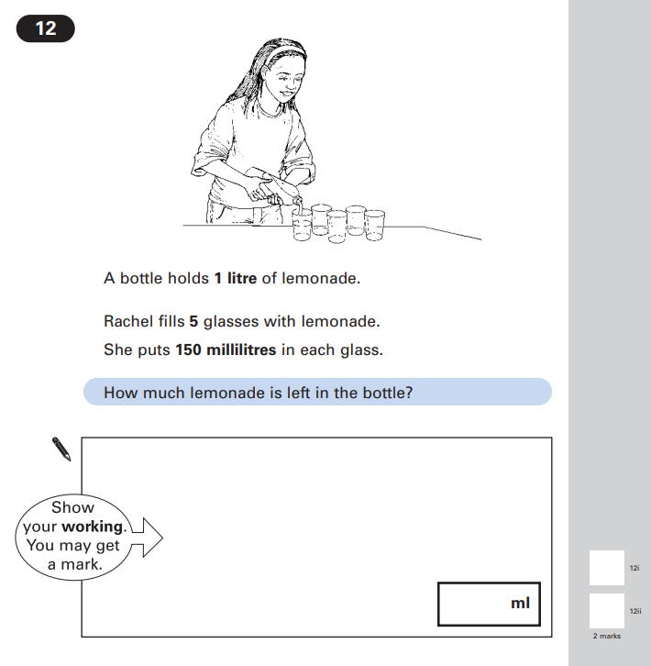

Key Stage 2: 2003 Paper A
2.
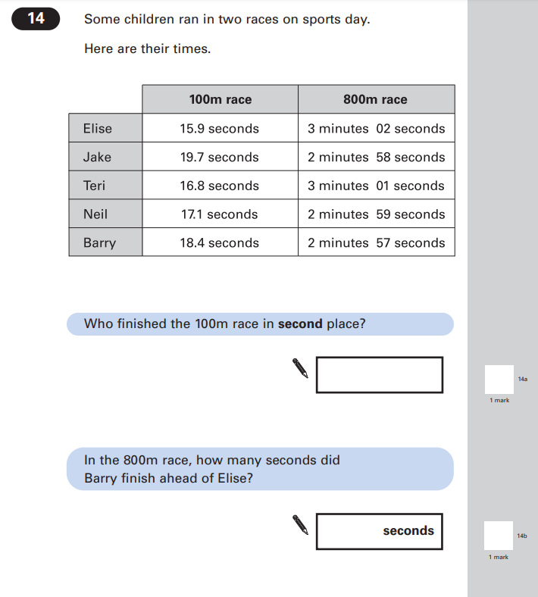

Key Stage 2: 2003 Paper A
3.
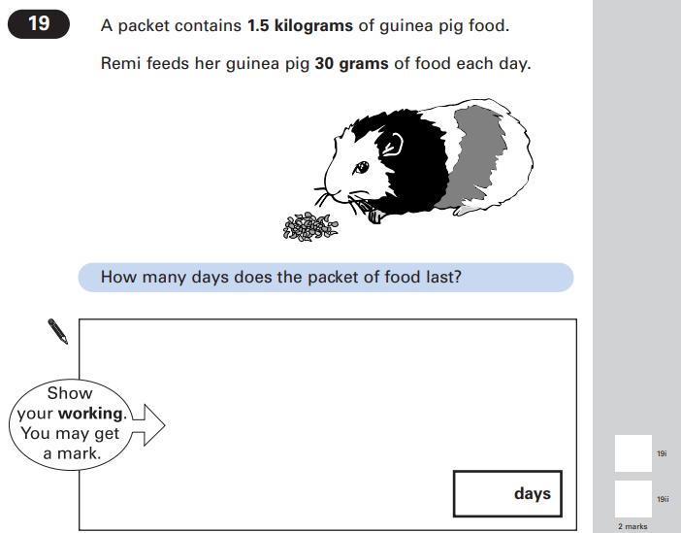

Key Stage 2: 2003 Paper B
1.
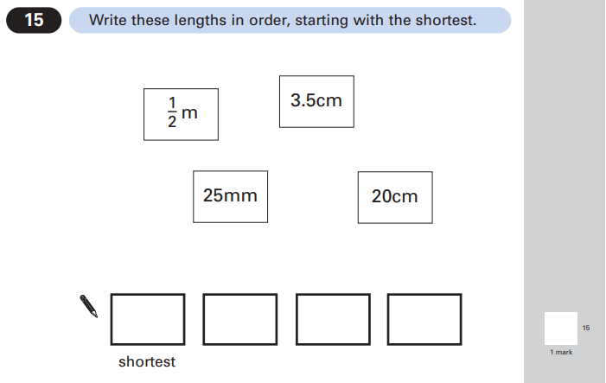

Key Stage 2: 2008 Paper A
1.
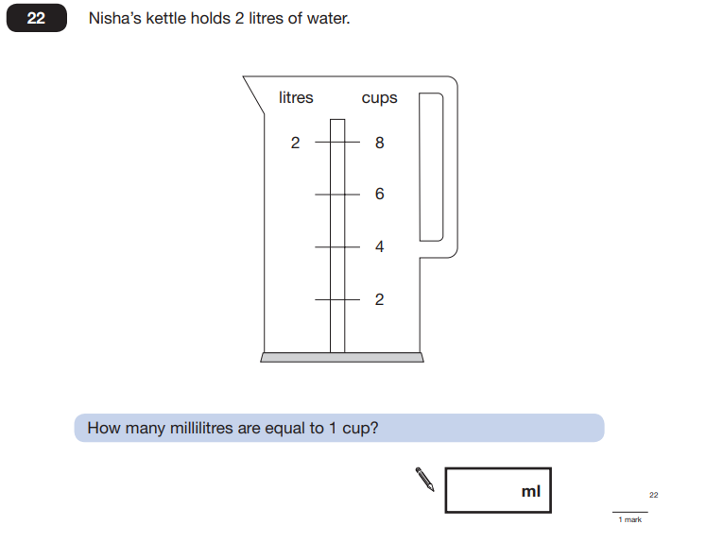

Key Stage 2: 2010 Paper B
1.
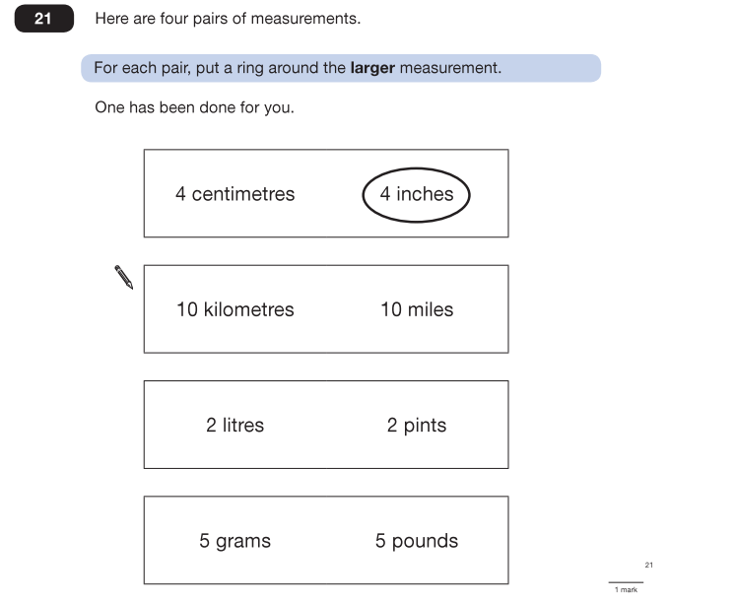

Key Stage 2: 2011 Paper B
1.
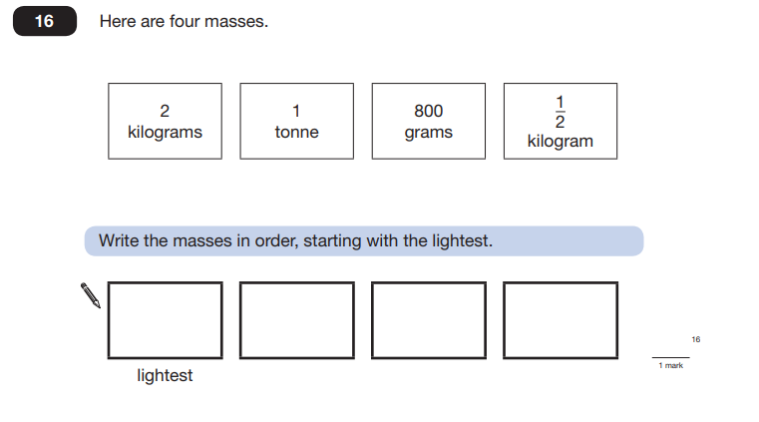

Key Stage 2: 2011 Paper B
2.
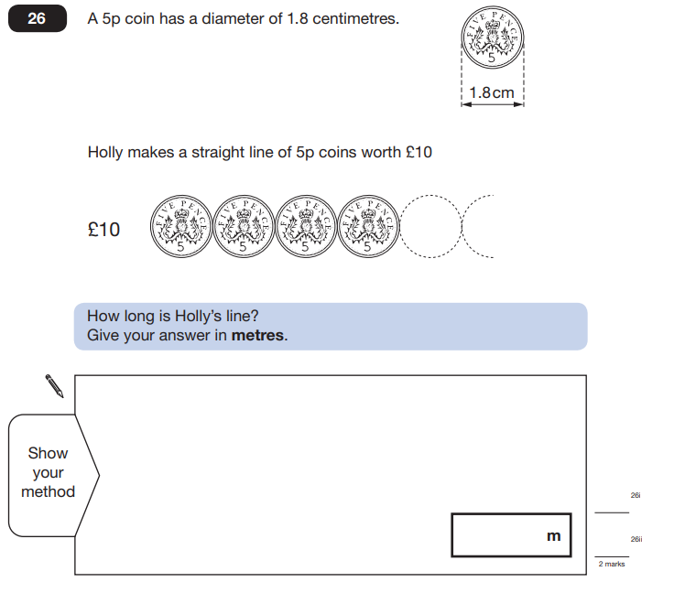

Key Stage 2: 2012 Paper A
1.
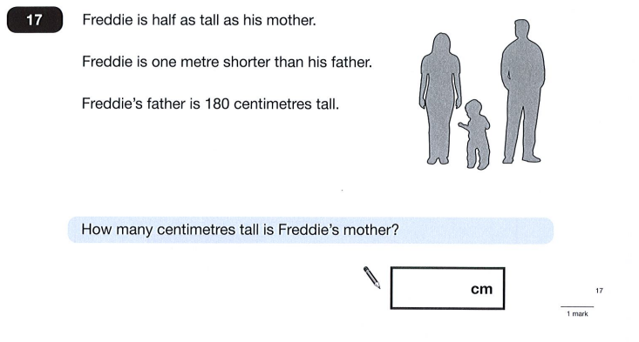

Key Stage 2: 2014 Paper B L6
1.
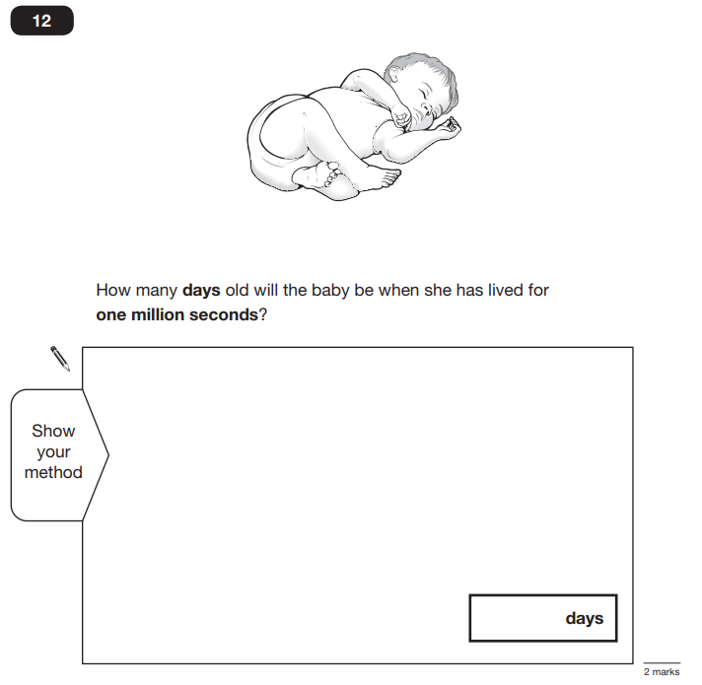

Key Stage 2: 2016 Paper 2 Reasoning - Sample
1.
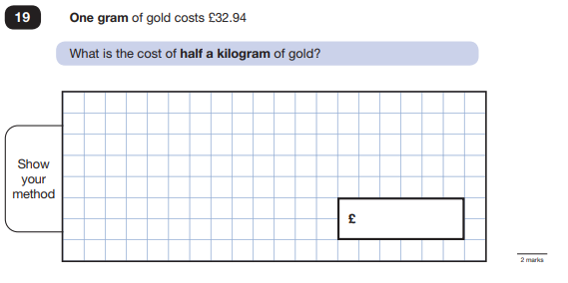

Key Stage 2: 2016 Paper 2 Reasoning
1.
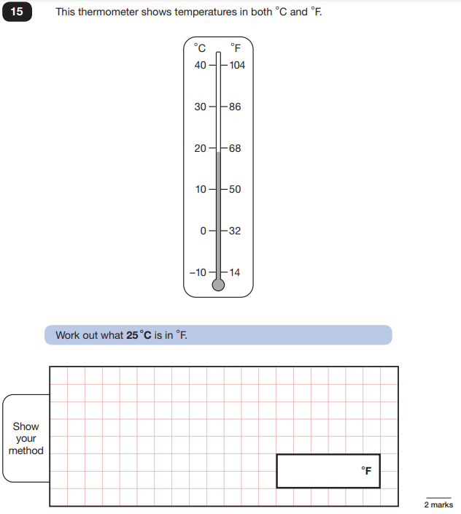

Key Stage 2: 2017 Paper 2 Reasoning
1.
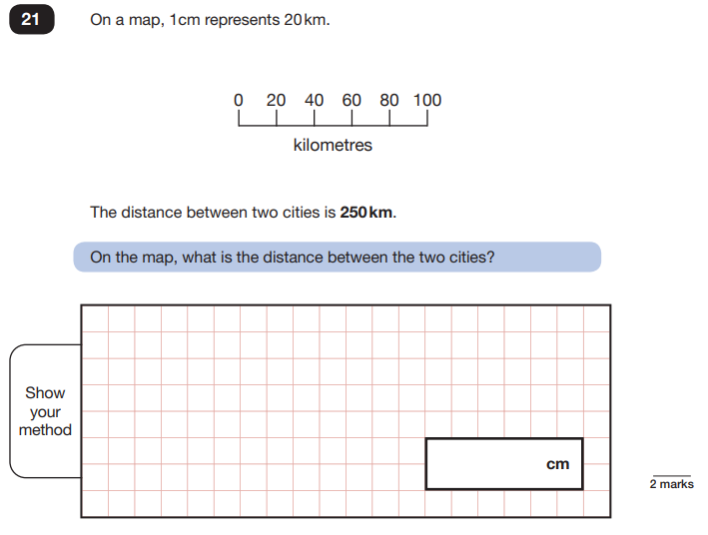

Key Stage 2: 2018 Paper 2 Reasoning
1.
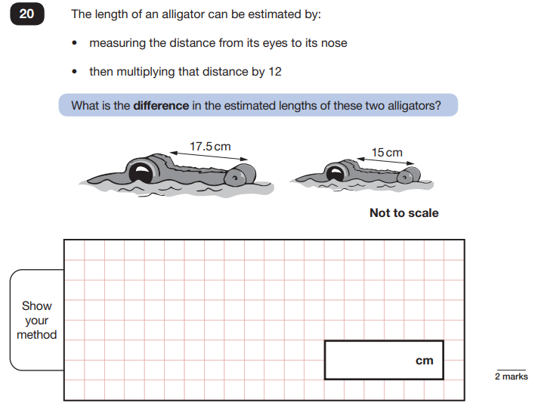
Key Stage 2: 2019 Paper 2 Reasoning
1.
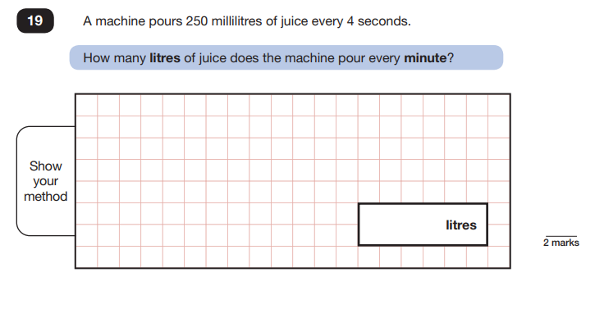
Key Stage 2: 2019 Paper 3 Reasoning
1.
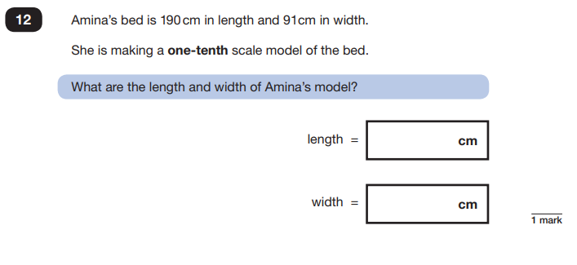
Key Stage 2: 2019 Paper 3 Reasoning
2.
